Data Flow Diagrams:

Project Design Phase-II
Data Flow Diagram & User Stories

Date | 04 July 2026
Team ID | SWTID-2026-4563
Project Name | Visualizing Housing Market Trends: An Analysis of  Sales Price and Features Using Tableau
Maximum Marks | 3 Marks

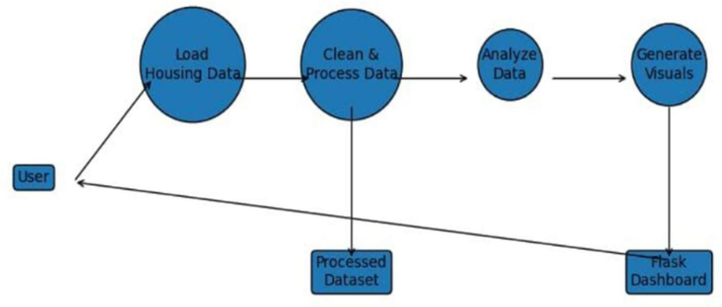

User Stories
Use the below template to list all the user stories for the product.
